

Database Design and Implementation Report

MOD002589

Faculty: Science and Technology

Department: Computing and Technology

Student ID: **2276245**

Your Team **2275502**

**2207397**

**2318637**

Academic Year: 2024/25

Trimester: 1

Contents

1 Requirement Analysis 4

1.1 Brief Introduction 4

1.2 List of data fields (Entities and their attributes) 4

2 Database design 6

2.1 Entity Relationship Modelling 7

2.1.1 Initial Entity Relationship Model 7

2.1.2 Extended Entity Relationship Model 8

2.2 Normalised Model 8

2.3 Database Schema 9

3. Mapping 11

4. Database implementation 16

5. SQL Queries 18

5.1 Query 1 18

5.1.2 Query in natural language (Question from the list provided on Canvas) 18

5.1.3 SQL Code and output 19

5.1.4 Explain the output of the data (was this what was predicted?) 19

5.2 Query 2 19

5.9 Query 9 **Error! Bookmark not defined.**

5.9.1 For what purpose will this query be used **Error! Bookmark not defined.**

5.9.2 Query in natural language **Error! Bookmark not defined.**

5.9.3 SQL Code and output **Error! Bookmark not defined.**

5.9.4 Explain the output of the data (was this what was predicted?) **Error! Bookmark not defined.**

5.10 Query 10 **Error! Bookmark not defined.**

5.10.1 For what purpose will this query be used **Error! Bookmark not defined.**

5.10.2 Query in natural language **Error! Bookmark not defined.**

5.10.3 SQL Code and output **Error! Bookmark not defined.**

5.10.4 Explain the output of the data (was this what was predicted?) **Error! Bookmark not defined.**

6. References 26

# Requirement Analysis

## 1.1 Brief Introduction

Together Culture Cambridge is a community-focused organisation dedicated to collaborating with the acts of sharing, caring, learning, experimenting and fostering an ecological creative economy. This report outlines the step that is taken to design and implement a database solution tailored to Together Culture’s operational and strategic needs.

## 1.2 List of data fields (Entities and their attributes)

**NonMember**

NonMemberID, Name, Email, EngagementScore, InterestArea, ConversionStatus

**Registration**

RegistrationID, NonMemberID, InterestArea, RegistrationSource, Feedback, ConversionDate

**EngagementLog**

EngagementID, EngagementType, EngagementTime, EngagementScore, ConsentStatus

**CRM**

CRMID, MemberID, EngagementLogID, CampaignAssociation

**Member**

MemberID, Name, Email, Phone, MemberType, JoinDate, SubscriptionEnd, EngagementFlags, Authentication

**Membership**

MembershipID, MemberID, Tier, Type, TypeDescription

**Survey**

SurveyID, MemberID, Feedback, DetailsShared, Department

**Event**

EventID, EventName, Date, Location, Capacity, Description

**SpaceUtilisation**

UtilisationID, EventID, Date, TimeSlot, CapacityUsed, SpaceDetails, UtilisationPattern

**EventParticipation**

ParticipationID, MemberID, EventID, ParticipationDate, ParticipationStatus, Engagement

**AttendanceLog**

AttendanceID, MemberID, EventID, CheckInTime, CheckOutTime, AttendanceStatus

**Alerts**

AlertID, MemberID, AlertType, AlertDetails, AlertDate, ResolveStatus

**Payment**

PaymentID, MemberID, Amount, PaymentDate, PaymentMethod, InvoiceID

**Invoice**

InvoiceID, InvoiceName, InvoiceDescription

# Database design (20%)

## 2.1 Entity Relationship Modelling

### Initial Entity Relationship Model

This is our simpler ERD that we used to make our more complex EERD.

### 2.1.2 Extended Entity Relationship Model

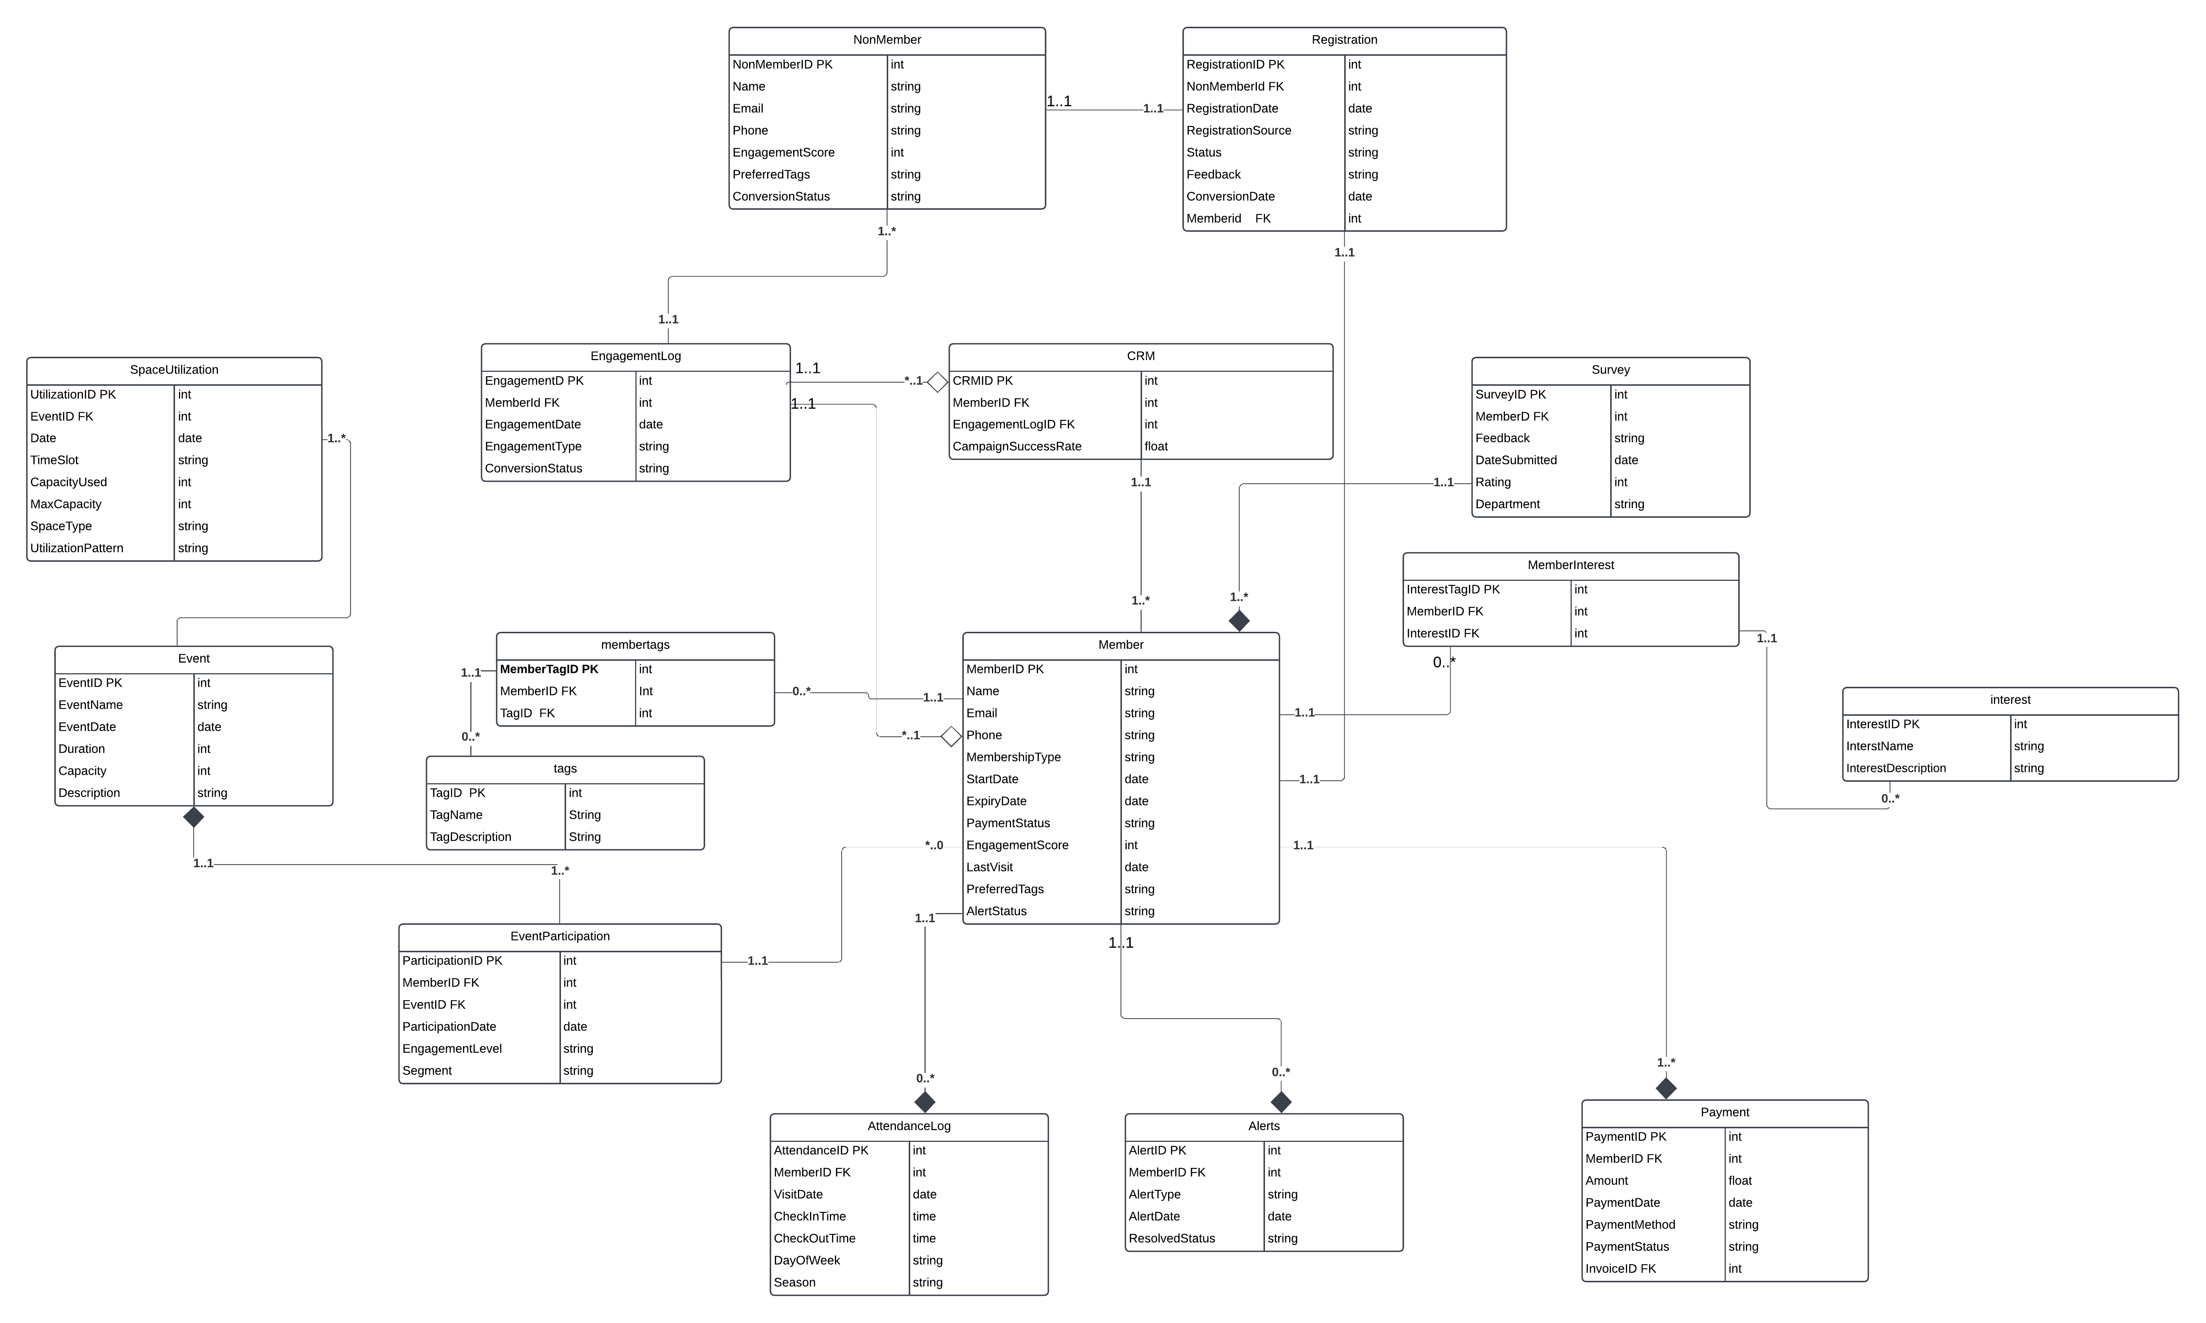

## 2.2 Normalised Model

**The EERD is validated through normalization steps. All tables are in 1NF as their attributes are atomic, and there are no repeating groups. Moving to 2NF, composite keys like ParticipationID in EventParticipation ensure that all non-key attributes fully depend on the key. For 3NF, transitive dependencies are removed, as seen in the Event table where attributes like EventName and Capacity depend solely on EventID. Many-to-many relationships, such as between Member and Event, are resolved with a linking table (EventParticipation), ensuring database design**

## 2.3 Database Schema

|  |  |  |  |  |
| --- | --- | --- | --- | --- |
| Attribute | Data Type | Primary Key (PK) | Foreign Key (FK) | Description |
| MemberID | INT | Yes | No | Unique ID for each member. |
| Name | VARCHAR(100) | No | No | Full name of the member. |
| Email | VARCHAR(100) | No | No | Email address of the member. |
| Phone | VARCHAR(15) | No | No | Contact number of the member. |
| MembershipType | VARCHAR(50) | No | No | Type of membership (e.g., Gold). |
| StartDate | DATE | No | No | Start date of the membership. |
| ExpiryDate | DATE | No | No | Expiry date of the membership. |
| PaymentStatus | VARCHAR(20) | No | No | Status of payment (e.g., Paid). |
| EngagementScore | FLOAT | No | No | Engagement level of the member. |
| LastVisit | DATE | No | No | Last recorded visit. |

# 3. Mapping (10%)

|  |  |
| --- | --- |
| Question | Maps To |
| **GENERAL USAGE PATTERNS** | |
| What times of the day are busiest? | Users, Attendance log. |
| What are the overall patterns of members’ use of the space over time? | Attendance log, Member, Space Utilisation |
| Which days of the week see the highest member attendance? | Attendance log, Member |
| How do usage patterns vary between weekdays and weekends? | Attendance log |
| Are there any seasonal variations in space usage? | Space Utilisation and Attendance log |
| **INDIVIDUAL MEMBER USAGE** | |
| When are individual members visiting the space most frequently? | Attendance log, ,Member |
| Can we track if a particular member's attendance has changed over time? | Group by, Attendance log, Member Usage |
| Has a member's usage increased significantly, indicating higher engagement? | Member ID, Attendance log, Member Usage |
| Has a member been absent for an extended period, suggesting possible attrition risk? | Member ID, Attendance log, Member Usage |
| Can we generate alerts for unusual changes in individual member attendance patterns? | Member ID, Attendance log, Alerts |
| **EVENT PARTICIPATIONS AND INTERESTS** | |
| What types of events are members most interested in? | Event, Member ID |
| Can we use a system of tags to track areas of interest for members? | Member ID, Member log |
| How many events has each member attended within a specific period? | Member ID, Member Name, Group |
| |  | | --- | |  |  |  | | --- | | Which events have the highest attendance rates? | | Event ID, Event name, Group by |
| Can we identify trends in event participation among different member segments? | Member ID, Member Type, Group by |
| How do event interests correlate with members' overall engagement and space usage? | Event tag, Engagement log |
| **AUDIENCE SEGMENTATION** | |
| Can we segment potential members based on their interests and interactions before joining? | Member Interaction, NonMember, EngagementLog, MemberInterestTags |
| How effective are our current acquisition strategies based on engagement data? | CRM, EngagementLog |
| What is the average volume of digital engagements before converting to membership? | EngagementLog, Registration |
| Can we track and respond to potential members' interests more effectively? | NonMember, MemberInterestTag |
| |  | | --- | |  |  |  | | --- | | How can we personalize communication with members based on their segmented interests? | | Member, MemberInterestTags |
| **SPACE UTILIZATION** | |
| What is the average capacity utilization of the space at different times? | SpaceUtilization, Member log |
| How can we optimize workspace allocation to ensure a dynamic and integrated community? | SpaceUtilization |
| |  | | --- | |  |   Are there specific areas within the space that are underutilized? | SpaceUtilization |
| |  | | --- | | How can we avoid having segregated areas and promote mixing of different disciplines? | | SpaceUtilization |
| REPORTING AND INTEGRATION | |
| Can we generate detailed reports on student member activity for organizational members? | CRM, Reports |
| Can we automate data entry processes and report generation to reduce manual efforts? | Reports, AutomationLogs |
| How easily can we pull reports from the CRM that provide the necessary insights? | CRM |
| Are there any data integrity issues we need to address during integration? | CRM, DataIntegrityLogs |
| **USER JOURNEY AND ACQUISITIONS** | |
| How can we better track potential members' interactions before they join? | NonMember, EngagementLog |
| What tools can help us gather useful data on digital engagements? | IntegrationLogs |
| |  | | --- | |  |  |  | | --- | | What additional insights can tools like Mouseflow and Hotjar provide to improve engagement? | | IntegrationLogs, CRM |

# 4. Database implementation (10%)



# 5. SQL Queries (50%)

a) What types of events are members most interested in (e.g., wellbeing, citizenship)

b) Which events have the highest attendance rates?

c) Which days of the week have the highest member attendance?

d) What is the average volume of digital engagements before converting to membership?

e) How do usage patterns vary between weekdays and weekends?

f) What times of day are the busiest?

g) Can we use a system of tags to track areas of interest for members?

h) how many members have unsubscribed and why?

i) how many members visited the site every day?

j) How many members are near their membership renewal dates?

## 5.1 Query 1

### 5.1.2 Query in natural language (Question from the list provided on Canvas)

a) What types of events are members most interested in (e.g., wellbeing, citizenship)

### 5.1.3 SQL Code and output

### 5.1.4 Explain the output of the data (was this what was predicted?)

It was expected that events focusing on **wellbeing** and **citizenship** would dominate, as these topics align with current trends emphasizing mental health, social responsibility, and self-improvement.

## 5.2 Query 2

b) Which events have the highest attendance rates?

The query found the events with the highest attendance rates by looking at how full each event was compared to its capacity**.**

5.3 Query 3

c) Which days of the week have the highest member attendance?

The query looked at which days of the week had the highest attendance by counting how many members showed up on each day.

1. **Saturday** had the most attendance. This means members prefer weekend events, especially on Saturdays.
2. **Wednesday** was the second most popular day, showing that mid-week events also do well.
3. **Sunday** ranked third, reinforcing that weekends are a great time to engage members

**d)** What is the average volume of digital engagements before converting to membership?

The query calculated the average number of digital engagements that members had before they decided to sign up as members.

e) How do usage patterns vary between weekdays and weekends?

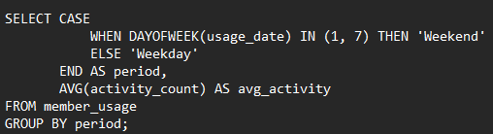

The query compared how much time members use the system on weekdays versus weekends.

f) What times of day are the busiest?

The query looked at which times of day had the most activity from members. The busiest times are in the **evening**, especially **6 PM**, followed by **7 PM**, **8 PM**, and **5 PM**. Members are most active during these hours, likely after work or school.

g) Can we use a system of tags to track areas of interest for members?

The query analyzed how often members are associated with specific tags (like interests or preferences). Tags can effectively track what members are interested in. They show which topics are popular, helping to personalize events and content for members.

h) how many members have unsubscribed and why?

This means 45 members chose "Lack of Interest" as their reason for unsubscribing in the member_unsubscriptions table.

i)how many members visited the site every day?

the output depends on the actual site usage data, how many different members accessed the site each day. The query just counts and organizes that information.

Purpose - Track User Activity Trends, Engagement, Evaluate Marketing or Event Impact

J) How many members are near their membership renewal dates?

The output shows only the members whose memberships are close to expiring (within 30 days), based on the current date and the membership data.

Purpose - by identifying members with upcoming renewal dates, the organization can send timely reminders (via email, SMS, etc.) to encourage renewal, Revenue Forecasting, Customer Support Preparation.

# 6. References

I got my material and resources I used for this from these websites and study sites  
<https://www.techradar.com/features/should-you-cancel-netflix?utm_source=chatgpt.com>

<https://www.statista.com/statistics/272014/global-social-networks-ranked-by-number-of-users/?utm_source=chatgpt.com>

<https://www.statista.com/statistics/272014/global-social-networks-ranked-by-number-of-users/>

<https://datareportal.com/social-media-users>

<https://khoros.com/resources/social-media-demographics-guide>

<https://www.wallstreetprep.com/knowledge/daily-active-users-dau/>